**Design Documentation**

**Hackathon Orange Team**

**By:**

Jonathan Paulson

Jan-Gerd Tenberge

Niculae Mandache

Mustafa

Arip Permana

1. **Introduction**

The developed system will display an animation on square display of 32 x 32 LED matrix modules.

1. **Technical Specification**
2. Programming Language : C++, Objective C
3. Version control : GIT
4. **Development Environment**
5. USB to UART driver
6. Editor : Visual Studio Code, Xcode
7. IoT Development Environment using Plafrom IO
8. **Infrastructure Services**
9. Huzzah Feather ESP8266@80MHz
10. Chain of four MAX7219 8x8 dot matrix LED modules
11. Five wire female-female jumper wires
12. USB A to mirco-USB B cable
13. 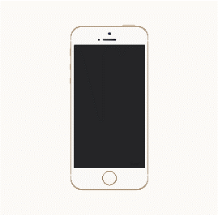**System Architechture**

Huzzah Feather ESP8266@80MHz

**Web Server**

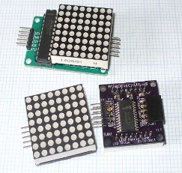

[This Photo](http://tronixstuff.com/2013/10/11/tutorial-arduino-max7219-led-display-driver-ic/) by Unknown Author is licensed under [CC BY-SA-NC](https://creativecommons.org/licenses/by-nc-sa/3.0/)